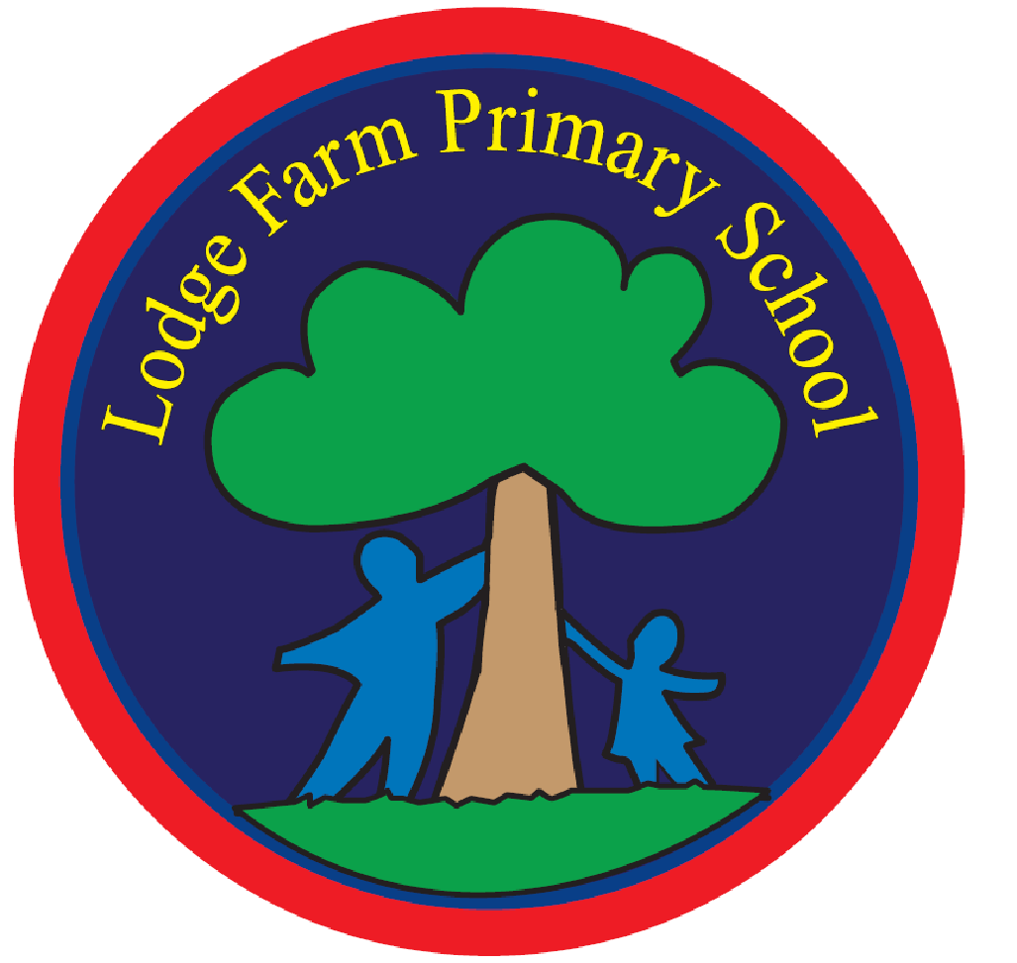  “Learning in mind, community at heart” | Lodge Farm Primary School  Mobbsbury Way  Chells  Stevenage  Herts  SG2 0HR  Tel: 01438 236600
email: admin@lodgefarm.herts.sch.uk  www. lodgefarm.herts.sch.uk | Acting Headteacher: Mrs Smith
Thursday 26th September 2024

Dear Parents/carers,

On Wednesday 27th November 2024, Year 3 will be attending an all-day experience at Celtic Harmony camp in Hertford. The children will have the opportunity to develop their understanding of the Stone Age and immerse themselves in a Stone Age experience. This trip is to support their learning during history this term.

The children will need to arrive at Lodge Farm at normal time at 8:40am because the coach will be leaving at 9:15 am. Dependent on traffic, we will be aiming to return to Lodge Farm at normal time (3:20 pm). Please pick up from school at the classroom door or your normal end of day arrangement. If we arrive back to school later than planned, we will inform you via text message.

On the day of the trip, your child will need to bring:
- A packed lunch or contact the office for a school packed lunch
- An additional snack (optional)
- A drink
- Wear school uniform and comfortable shoes
- Please wear appropriate clothing (e.g. coats, wellies) as parts of the day take place outside.

We will bring your child’s appropriate medication with us should they need this on the day.

The trip will be £29.00 per child. This covers the cost of the coach and Celtic Harmony. Both consent and payment can be made via School Gateway. These will need to be completed by Wednesday 13th November 2024.

If you do not wish your child to attend, please inform the office by Friday 8th November 2024 so alternative arrangements can be made for your child.

If you have any further questions or would like to speak to us about the trip, please do not hesitate to contact us.

Kind regards,
The Year 3 Team

